**MIT School of Engineering**

**Department of Computer Science and Engineering**

**Project Synopsis**

**Group ID: 3**

**Project Title: *CHATBOT BASED SONG RECOMMENDATION SYSTEM***

***Guide : Prof. Suresh Kapre***

**Group Members:**

|  |  |  |  |  |
| --- | --- | --- | --- | --- |
| **Enrollment Number** | **Roll No.** | **Name of student** | **Email Id** | **Contact Number** |
| **MITU22BTCS0615** | **2223475** | **Raashi Lokhande** | **raashilokhande@gmail.com** | **9284839431** |
| **MITU22BTCS0545** | **2223472** | **Prachi Kunjir** | **kunjirprachi234@gmail.com** | **9028227369** |
| **MITU22BTCS0755** | **2223486** | **Sayali Ingole** | **imsayali2903@gmail.com** | **9834851305** |
| **MITU22BTCS0880** | **2223491** | **Sushaan Satyam** | **sushaansatyam0307@gmail.com** | **9955352992** |

**Problem Statement:**

Music listener is a person who listens to music as per his/her mood ,Who needs Logs into the personalized song recommendation system, who can receive a list of personalized song recommendations according to their mood and relevant factors because they have Limited Music Discovery, Inaccurate Mood Detection and Lack of Personalization .

**Solution-**

The chatbot may ask users questions about their music tastes and then provide recommendations based on their responses. This can assist users in learning more about their own musical likes and discovering new songs that they may not have discovered otherwise.

**Abstract:**

1. **Empathy**

|  |  |
| --- | --- |
| What Music listener Says  (Direct Statements)   * Difficulty in Expressing Preferences * Limited Music Discovery * Inaccurate Mood Detection * Cross-Platform Integration * Lack of Personalization | What Music listener Thinks  (client thinks about their experience).   * Concerned about privacy issues. * Desires better music discovery. * Frustrated with inaccurate mood detection.   Seeks improved contextual  awareness. |
| What Music listener Does  (Actions that user/client  takes)   * Logs into the personalized song recommendation system. * Indicates or selects their current mood. * Requests for song recommendations based on the provided information. * Receives a list of personalized song recommendations according to their mood and relevant factors. * Can provide feedback on the recommended songs to improve future recommendations. | What Music listener Feels  (Empathize User mental state of user/ client)   * Mood: Happy, sad, excited, relaxed, energetic, nostalgic, calm, anxious, etc. * Relevance: Hopeful that the system will consider their preferences accurately, curious about new music options, eager to find suitable songs for their current mood and situation. |

1. **Ideation**

|  |  |  |  |
| --- | --- | --- | --- |
| **Sr. No.** | **Requirement** | **Proposed Solution** | |
| **1.** | Available Solutions-  **Integration of music streaming services**  Use the chatbot system to access customer preferences and playlists by integrating the APIs of well-known music streaming services (such as Spotify, Apple Music, and YouTube Music). To determine musical taste, examine user interactions and listening history. | Proposed Solution-  Use API integration to gain access to user information, such as listening history, favorite genres, and playlists, from well-known music streaming services. Make personalized music recommendations using machine learning algorithms to analyze this data inside the chatbot interface. | |
| **2.** | Available Solutions-  **Real-time interaction**.  Create a chatbot that can engage people in real-time chats and is responsive. To focus on specific music recommendations, the chatbot should inquire about your mood, activity, or preferences. | | Proposed Solution-  Make a chatbot interface that is lively and engaging and encourages users to converse in natural language. Utilize sentiment analysis and context-based inquiry to comprehend user preferences and emotional state so that the chatbot may make appropriate song recommendations. |
| **3.** | Available Solutions-  **Multi-platform accessibility**  Make sure the chatbot can be used on a variety of platforms and devices, including web browsers, mobile apps, and voice assistants (such as Amazon Alexa and Google Assistant). | | Proposed Solution-  Create a cross-platform solution that can be accessed through web interfaces, certain mobile apps, and voice-activated hardware. Implement seamless user preference and history synchronization across several platforms so that users can communicate with the chatbot regardless of the device they are using. |

**Literature Survey: Detail survey done**

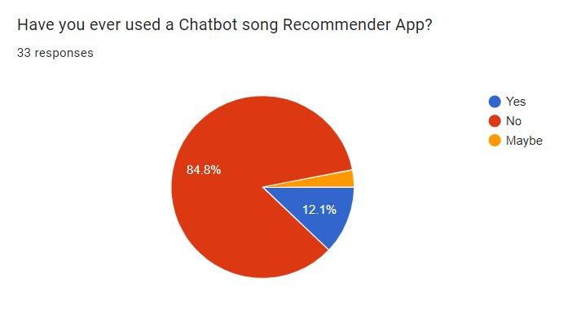

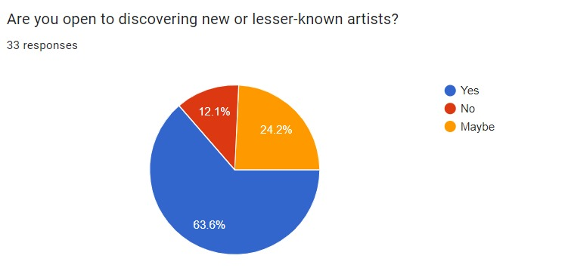

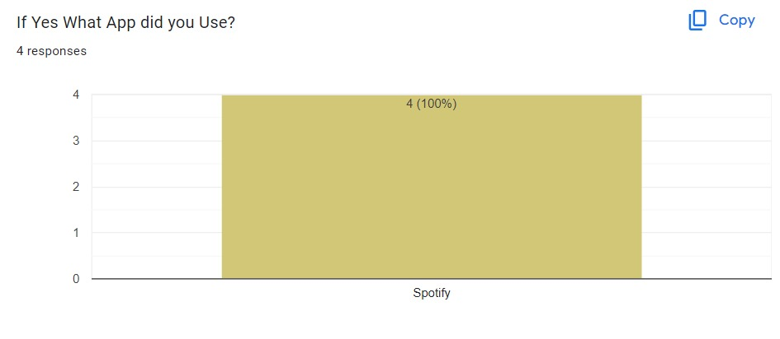

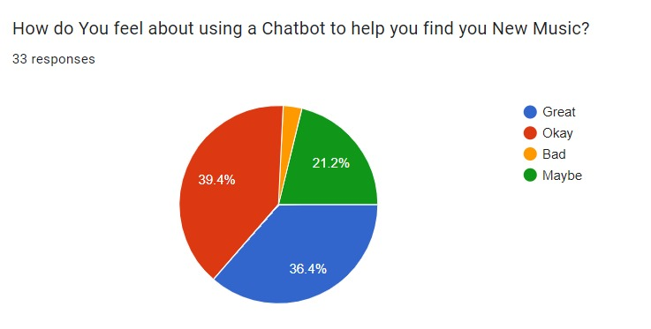

**Proposed System (Block Diagram):**

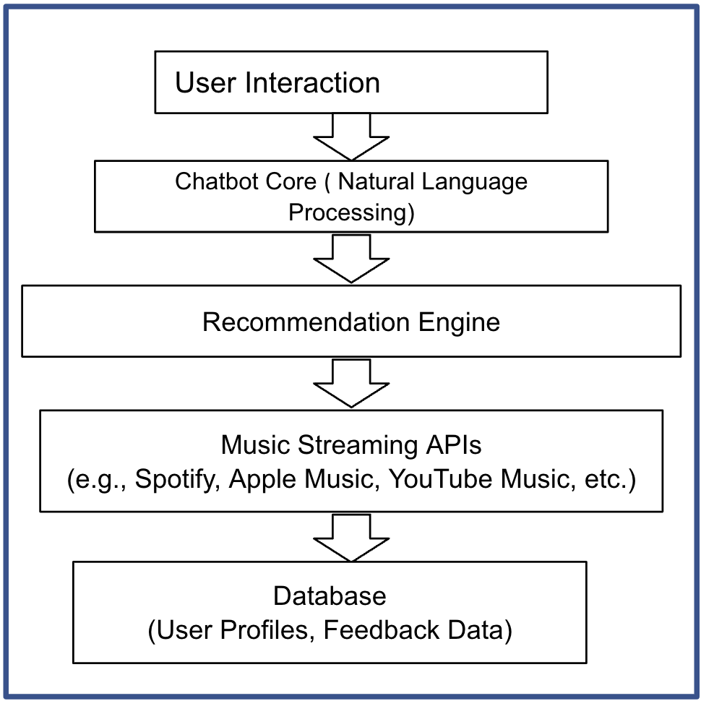

**Conclusion:**

**Scope-**

The Chatbot's user initiates the conservation.

The interaction is subjected to emotional analysis.

Receives the chatbot's response to the conservation.

Top tracks are found based on the emotion that the app detects.

The user moves to the music!

**References:**

1. https://www.udemy.com/course/create-a-python-powered-chatbot-in-under-60-minutes/learn/lecture/12959068?start=30#overview
2. https://www.youtube.com/live/ynE7p65jLts?si=2I1H1BvsZzP0rMI4